Josh Creasey

Data Structures

Final Simulation

**Final Spec. Doc.**

**Initial Design ~**

**Seen above is my intital layout design for the simulation project from the given design requirements posted on Whitgit. I used this document as a basic starting point in which I could begin developing code as I wanted to lay out all pieces of the structure before actually attempting to build the structure.**

**In my second revision of the system, I studied the examples in the textbook and attempted to develop a similar structure. This helped me get very close to my final design even though all of these aspects of the design in this form do not connect or form together to make a cohesive product.**

**Final Design ~**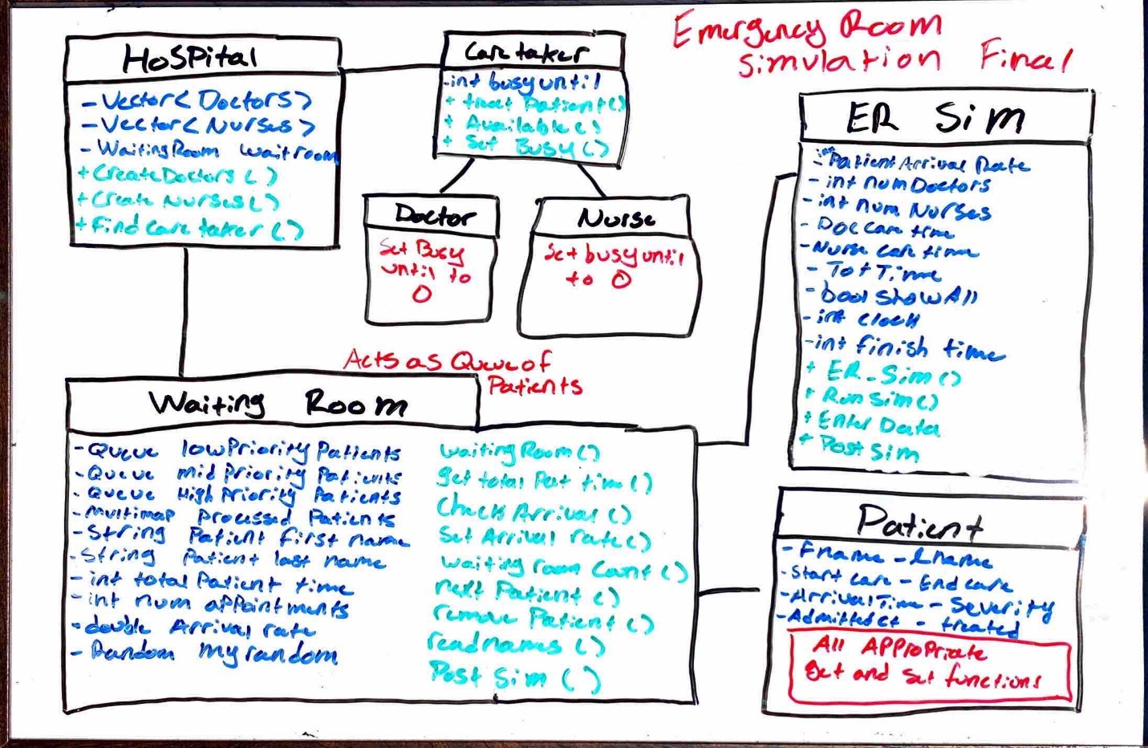

**This is the final UML design in which the emergency room simulation occurs. A hospital contains a waiting room and caretakers that take the form of either doctors or nurses. The waiting room acts as a queue of patients which is managed by the ER_Sim. Each patient that arrives is triaged into an appropriate queue within the waiting room based on the severity of their illness. If a doctor or nurse is available to help a patient they are removed from the waiting room and processed with all their information as well as how long they were in the emergency room. All information about a patient can be viewed by the user in a variety of ways. The user can choose to see all patients treated, look up a patient by name, or view all statistics of the simulation.**

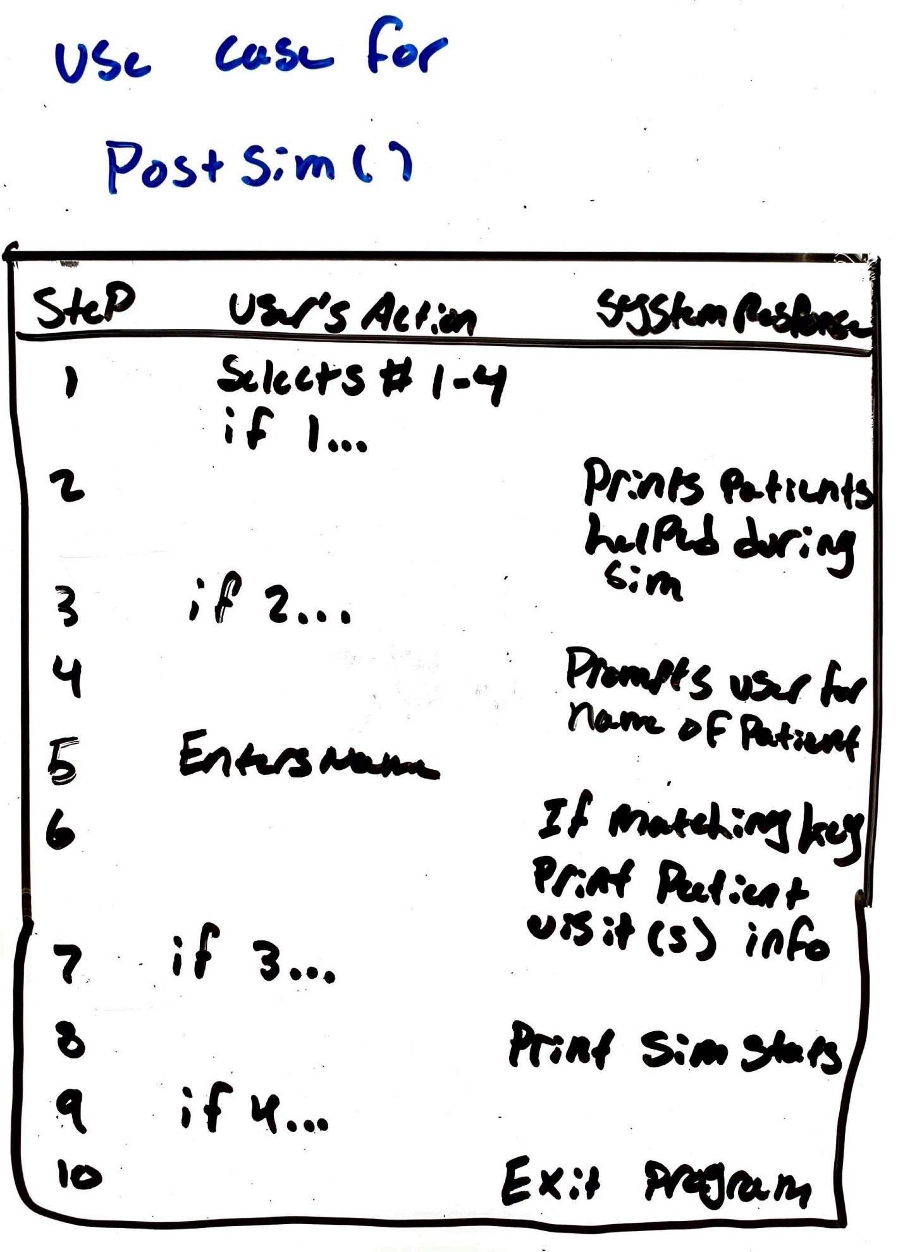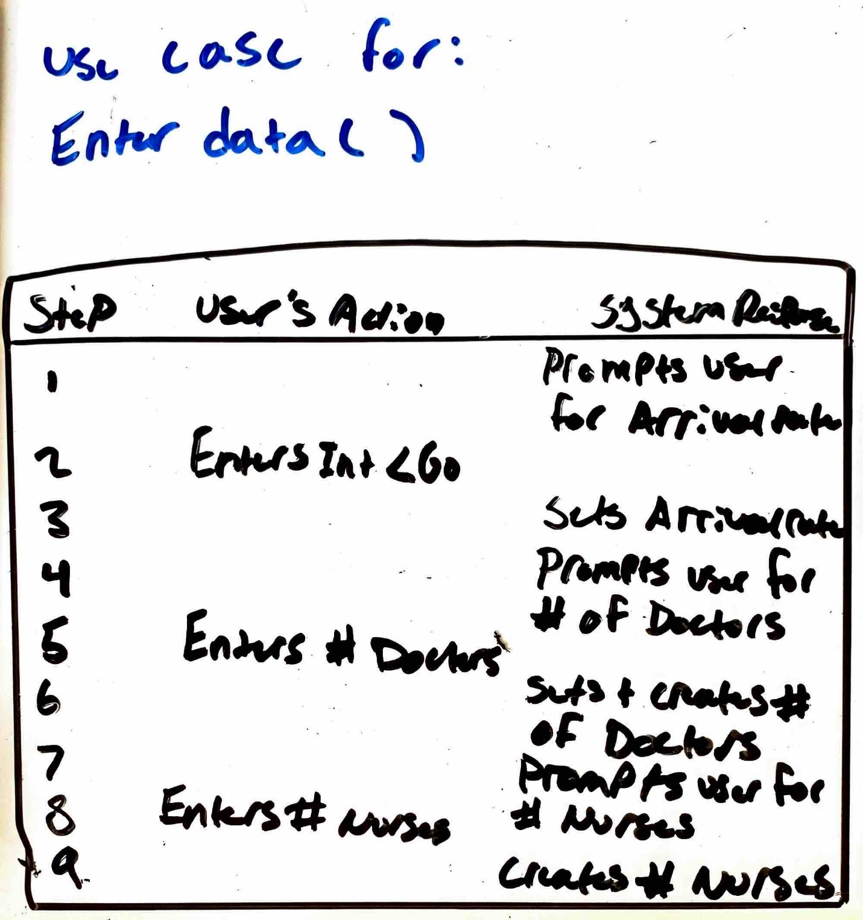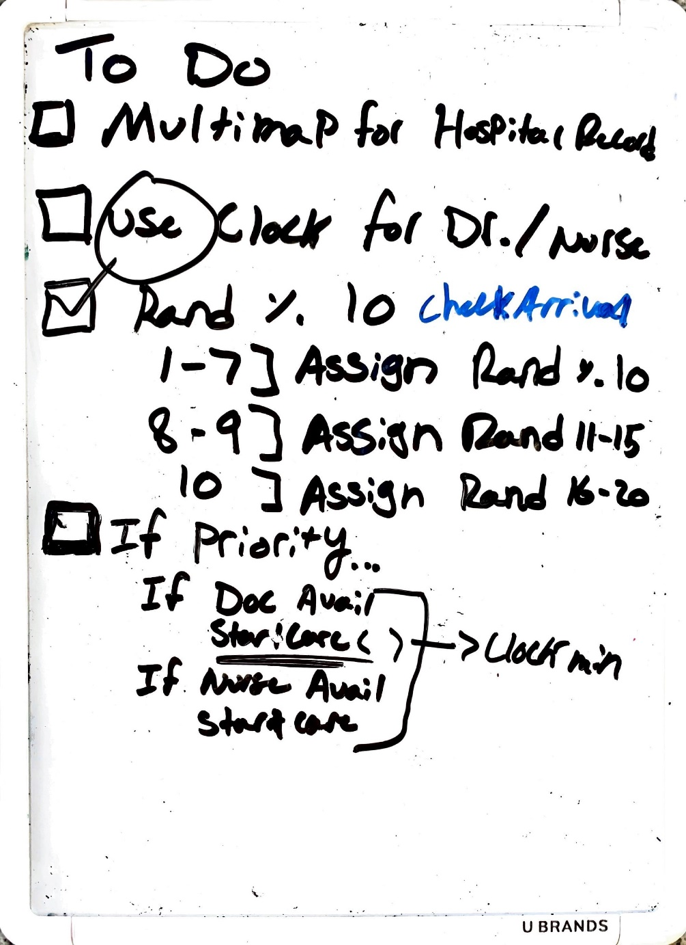

**I have included this short to do list I made while developing the simulation.**